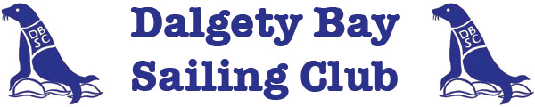

“Gavin Adamson Memorial Trophy” Race

Sunday 26 August 2018

DBSC invites all interested sailors to the annual Gavin Adamson memorial race. Gavin was a regular visitor to many clubs around the Forth and this race celebrates his ethos towards sailing by encouraging as many participants of mixed ability to participate and savour the enjoyment of sailing. There will be three race divisions, including one for “white-sail” boats, each with a different course. All entry fees are donated to Macmillan Cancer Relief.

The courses feature a tour of many of the clubs which Gavin enjoyed visiting and are designed with the aim of all participants sailing in similar tidal and weather conditions, as far as possible.

Any crews wishing to visit the DBSC clubhouse afterwards for refreshments or food will receive a warm welcome.

Organising Authority: Dalgety Bay Sailing Club.
Contact is Sailing Secretary (Keelboats).
Email – keelboatracers@dalgetybaysc.org

Sailing Area: East and West of the Forth bridges

Classes: Division 1, 2 (Handicaps as defined by the FYCA Rules), Cruiser

Programme: 1 race will be sailed for all classes.
Racing will commence and finish off Dalgety Bay Sailing Club.
First Warning Signal will be at 12.25 HRS

Registration: Sunday 26 August at Dalgety Bay Sailing Club until 1130 or
in advance to: Sailing Secretary (Keelboats)
Dalgety Bay Sailing Club
The Wynd
Dalgety Bay, Fife, KY11 9SB.

Prizes: The Gavin Adamson Memorial Trophy will be presented to the winner at the DBSC Annual Prize Giving

Entry: £5 for all yachts

Rules: The Race will be sailed under the prescription of ISAF, the RYA and the Race Sailing Instructions.
Sailing Instructions and entry forms will be available from Dalgety Bay Sailing Club or on the following websites www.fyca.org.uk www.dalgetybaysc.org

